Dojo Manager — Design Document
How to use this file: This is your Design Document draft, written to match the PAT rubric section 2 (Design Document, 30 marks). Copy it into Word/Google Docs, turn the headings below into your title page + table of contents, and add the screenshots where marked with [ADD SCREENSHOT]. The diagrams are written in "mermaid" — open this file's preview in Cursor to see them drawn, then screenshot them into your document (or redraw them in draw.io / Word).

Title Page (rebuild this as page 1 in Word)
- Project title: Dojo Manager — Karate Student & Class Management System
- Document: Design Document
- Learner name:[your name]
- Exam number:[your exam number]
- Subject: Information Technology (Grade 12 PAT 2026)
- Date:[date]

Table of Contents (Word will build this automatically from your headings)
- Program Flow Diagram
- User Interface Description
- Secondary Storage Design
- Explanation of Secondary Storage Design
- Class Diagrams for Backend Classes
- How the Backend Classes Relate to Secondary Storage

1. Program Flow Diagram (Rubric 2.1 — 5 marks)
The program is used by one user group: the dojo administrator / sensei. When the program starts it loads all saved data, then shows the main window with four tabs. The user can move freely between the tabs. Adding, editing or deleting any record automatically saves the data back to file.
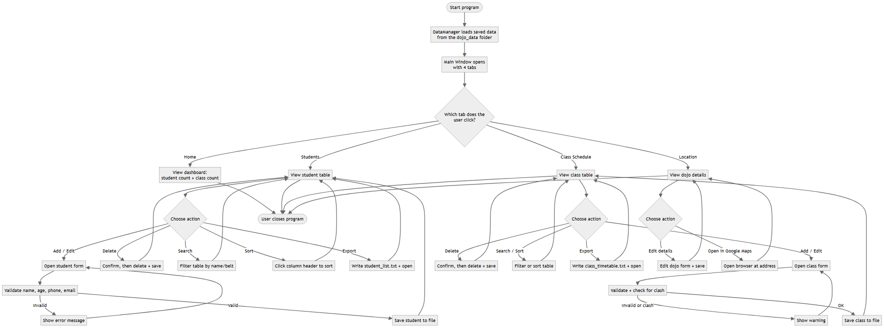
Explanation of the flow: There are no dead-ends — every screen returns the user to the tabs, and every data change ends in a save so nothing is lost.

2. User Interface Description (Rubric 2.2 — 6 marks)

2.1 Theme, colours, fonts and font sizes
The program uses a soft pink-and-white theme for a clean, friendly, modern look. All colours and fonts are defined in one place (UITheme.java) so every screen looks consistent.
Element | Setting used
Background | Light pink-white  RGB(255, 248, 251)
Panels / cards | White  RGB(255, 255, 255)
Header / title bars | Deep pink  RGB(196, 90, 130)
Primary buttons | Button pink  RGB(214, 110, 145)  with white text
Borders | Soft pink  RGB(245, 210, 225)
Main text | Charcoal  RGB(70, 55, 62)
Font (all screens) | Segoe UI
Title font size | 26–32 pt,  bold
Heading font size | 18 pt,  bold
Body font size | 14 pt, plain
Small / hint text | 12 pt, plain
Button font size | 13 pt,  bold

2.2 Purpose of each screen and its components
Screen 1 — Home / Dashboard(purpose: welcome the user and give a quick overview)
[ADD SCREENSHOT: Home tab]
Component | Type | Used for
Dojo name + subtitle | Labels | Branding / welcome banner
"Students registered" card | Label showing a number | Shows how many students exist
"Classes scheduled" card | Label showing a number | Shows how many classes exist
"Instructors" card | Label showing a number | Shows how many different instructors teach
"Today's classes" box | Panel of labels | Lists the classes running on the current weekday

Screen 2 — Students(purpose: view, search, add, edit and delete students)
[ADD SCREENSHOT: Students tab]
Component | Type | Used for
Student table | JTable (sortable) | Lists all students (ID, name, age, belt, phone, email). Click a column header to sort; double-click a row to edit it
Find box | JTextField | Type to search by name or belt
Search / Clear | Buttons | Run or reset the search
Add / Edit / Delete / Export List / Refresh | Buttons | Manage students and save a text report
Add/Edit form | JDialog | Enter a student's details
Name, Age, Phone, Email | JTextFields | Type text/number values
Belt Rank | JComboBox (dropdown) | Choose from a fixed list of belts

Screen 3 — Class Schedule(purpose: manage the weekly class timetable)
[ADD SCREENSHOT: Class Schedule tab]
Component | Type | Used for
Class table | JTable (sortable) | Lists all classes (ID, name, day, time, instructor, belt level). Click a column header to sort; double-click a row to edit it
Find box + Search / Clear | JTextField + Buttons | Search by class name, day or instructor
Add / Edit / Delete / Export Timetable / Refresh | Buttons | Manage classes and save a text timetable
Class Name, Instructor, Belt Level | JTextFields | Type text values
Day | JComboBox | Choose Monday–Sunday
Start Time | JComboBox | Choose from a fixed list of times

Screen 4 — Location(purpose: show and edit the dojo's contact details and open it on a map)
[ADD SCREENSHOT: Location tab]
Component | Type | Used for
Dojo detail labels | Labels | Show name, sensei, address, city, phone, email
About the dojo | JTextArea (read-only) | Show notes about the dojo
Edit details | Button + JDialog | Change the dojo's details
Open in Google Maps | Button | Open the address in the web browser

2.3 Why these components were chosen
- Dropdowns (JComboBox) are used for belt rank, day and time so the user can only pick a valid value — this prevents typing mistakes.
- Text fields are used for free text like names and phone numbers.
- Tables are used because the data is a list of records, which is easiest to read in rows and columns.
- Dialogs (pop-up forms) keep data entry separate and tidy, so the main screen stays uncluttered.

3. Secondary Storage Design (Rubric 2.3 — 5 marks)
- Where is data stored?Locally, on the same computer, in a folder called dojo_data that the program creates automatically.
- What structure is used? The data is stored in three separate files (a form of local file storage), one for each logical group of data. Each file holds Java objects saved with object serialisation (a .dat file).
The data is logically separated into three groups:

File 1 — students.dat (stores all students)
Field | Data type | Description | Example
id | integer | Unique student number | 1
name | string | Full name | Thabo Molefe
age | integer | Age in years | 14
beltRank | string | Current belt | Yellow Belt
phone | string | Contact number | 0821112233
email | string | Email address | thabo@email.com

Sample data:
1 | Thabo Molefe | 14 | Yellow Belt | 0821112233 | thabo@email.com 2 | Aisha Patel | 16 | Green Belt | 0834445566 | aisha@email.com

File 2 — classes.dat (stores all classes)
Field | Data type | Description | Example
id | integer | Unique class number | 1
className | string | Name of the class | Beginners Class
dayOfWeek | string | Day it runs | Monday
startTime | string | Start time | 16:00
instructor | string | Who teaches it | Sensei Lee
beltLevel | string | Belt range for the class | White - Yellow

Sample data:
1 | Beginners Class | Monday | 16:00 | Sensei Lee | White - Yellow 2 | Kids Class | Monday | 17:00 | Sensei Patel | All belts

File 3 — dojo_info.dat (stores the single dojo record)
Field | Data type | Description | Example
dojoName | string | Name of the dojo | Shobu Karate Dojo
senseiName | string | Head instructor | Sensei Lee
address | string | Street address | 12 Main Road
city | string | City / country | Johannesburg, South Africa
phone | string | Dojo phone | 011 555 0199
email | string | Dojo email | info@shobudojo.co.za
notes | string | Short description | Traditional Shotokan karate for all ages.

Generated report files (output only)
As well as the three data files above, the program can write two readable text reports into the same dojo_data folder when the user clicks an Export button. These are output files for printing/checking — the program does not read them back in.
File | Created when | Contents
student_list.txt | "Export List" clicked | A tidy table of every student
class_timetable.txt | "Export Timetable" clicked | The weekly classes grouped by day

4. Explanation of Secondary Storage Design (Rubric 2.4 — 3 marks)
I chose local file storage using object serialisation for these reasons:
- It suits the scenario. A single dojo runs the program on one office computer, so the data does not need to be shared over the internet. Local storage is the simplest, fastest and most reliable choice for this.
- The data is naturally separated into groups (students, classes, dojo info), so using one file per group keeps everything organised and easy to understand.
- Serialisation is simple and safe for objects. Because my data is already stored in objects (Student, KarateClass, DojoInfo), Java can save and reload a whole list of objects in one step, so I do not have to manually split and re-join text every time.
Compared to other options:
- A full database (e.g. MySQL/MongoDB) would work, but it would need extra software installed and set up on every computer. That is more complex than a small single-dojo program needs, so it was not worth the extra difficulty.
- Plain text/CSV files are human-readable, which is an advantage, but I would have to write extra code to convert every object to text and back, and to handle commas inside values. Serialisation avoids that.
- Cloud storage would only be needed if several branches had to share data live, which is not part of this scenario.
So local serialised files give the best balance of simplicity and reliability for this project.

5. Class Diagrams for Backend Classes (Rubric 2.5 — 8 marks)
The backend is made of five classes. The three model classes describe the data, DataManager handles all storage, and Validation checks input. - means private and + means public (information hiding is applied — all fields are private and are reached through public get/set methods).
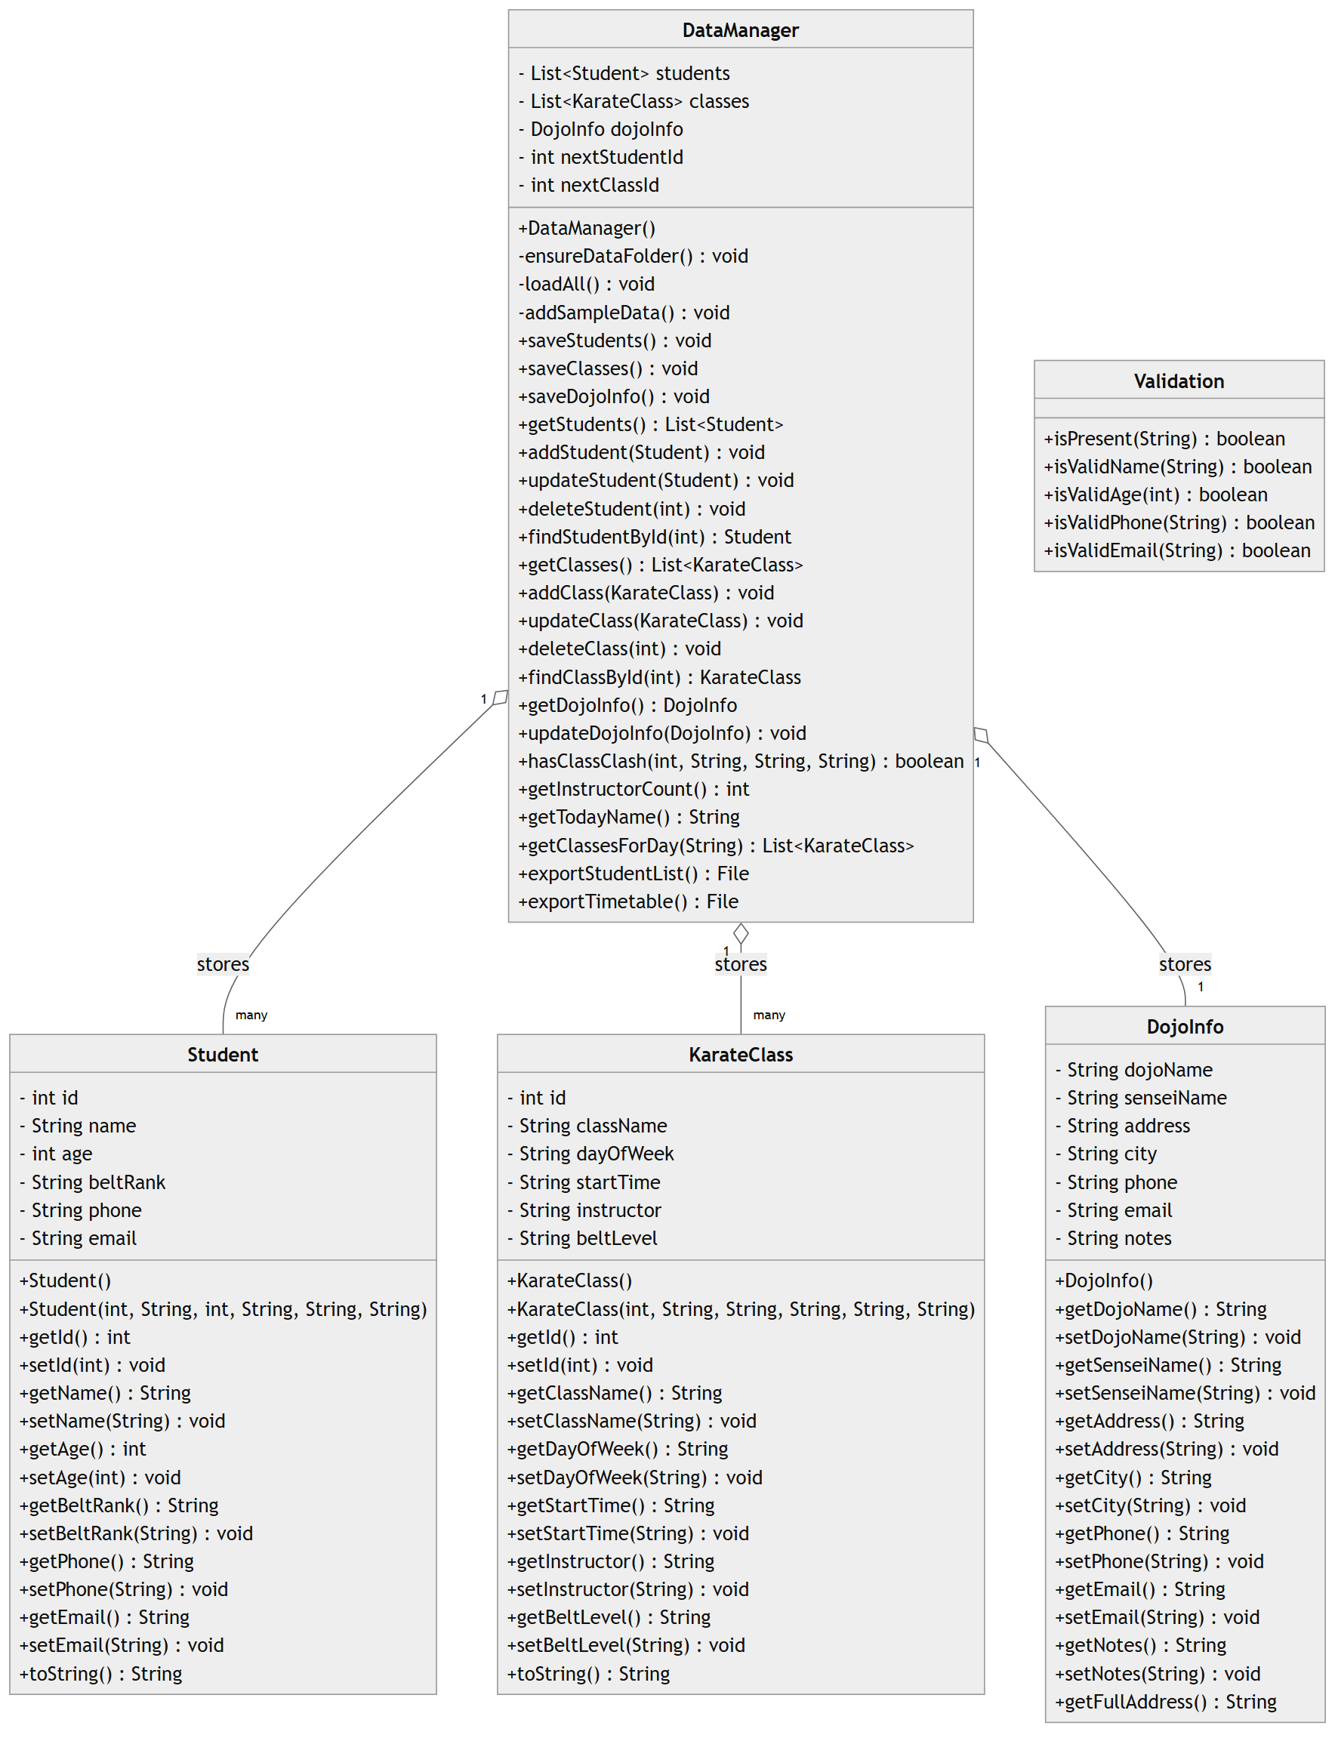
Method types used (as required by the rubric):
- Constructors: e.g. Student() and Student(int, String, ...).
- Accessors (get methods): e.g. getName(), getAge().
- Mutators (set methods): e.g. setName(String), setAge(int).
- Helper / auxiliary methods:ensureDataFolder(), addSampleData(), getFullAddress(), and all Validation methods.
- toString methods: in Student and KarateClass for showing them as text.

6. How the Backend Classes Relate to Secondary Storage (Rubric 2.6 — 3 marks)
Backend class | Stored in which file? | How it is used with storage
Student | students.dat | Each  Student  object is one row of student data.  DataManager  saves the whole list of  Student  objects to this file, and reads them back when the program starts.
KarateClass | classes.dat | Each  KarateClass  object is one class in the timetable.  DataManager  saves/loads the whole list to/from this file.
DojoInfo | dojo_info.dat | One  DojoInfo  object holds the dojo's own details and is saved to / loaded from this file.
DataManager | (controls all files) | This is the only class that reads and writes the files. It turns objects into saved data and saved data back into objects, and also writes the two readable text reports (  student_list.txt  ,  class_timetable.txt  ).
Validation | (no file) | Does not store anything itself; it checks data  before  DataManager  is asked to save it.

How data moves in and out of storage:
- Writing (saving): When the user adds/edits/deletes a record, the matching GUI screen calls a DataManager method (e.g. addStudent). DataManager updates its list in memory and then calls saveStudents(), which writes the full list of Student objects to students.dat.
- Reading (loading): When the program starts, DataManager's loadAll() method opens each file and rebuilds the lists of Student, KarateClass and DojoInfo objects so the data is exactly as it was left.
This shows a clear split: the model classes describe the data, DataManager moves that data to and from secondary storage, and the GUI classes only ask DataManager — they never touch the files themselves.
import mermaid from "https://cdn.jsdelivr.net/npm/mermaid@10/dist/mermaid.esm.min.mjs"; mermaid.initialize({ startOnLoad: true, theme: "neutral" });

